
Year 12 Mathematics Specialist 2017
Test Number 2: Functions and Graph Sketching
Resource Free
Name: ________Solutions__________________________ Teacher: DDA
Marks: 20
Time Allowed: 22 minutes
Instructions: You ARE NOT permitted any notes or calculator. Show your working where appropriate remembering you must show working for questions worth more than 2 marks.
_________________________________________________________________________
Question 1 [3 marks]
If $f\left(x\right)=1+\sqrt{x-2}$ determine the formula for $f^{-1}(x)$ the inverse of $f(x)$, and state its domain and range.
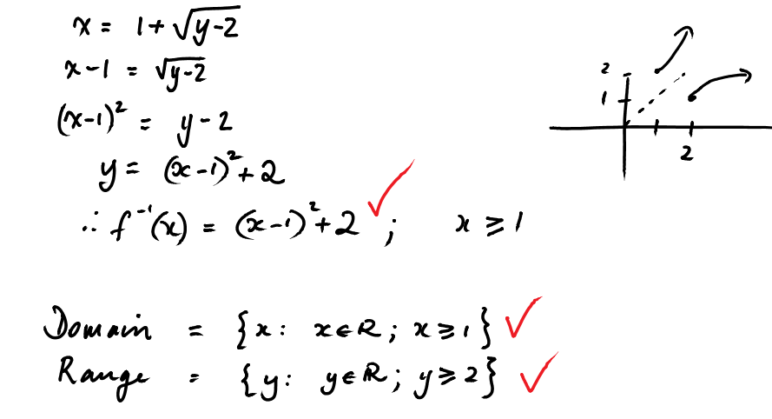

Question 2 [3 marks]
State the domain and range of $gof(x)$ if $f\left(x\right)=5\sqrt{x}$ and $g\left(x\right)=x^{2}+x$.
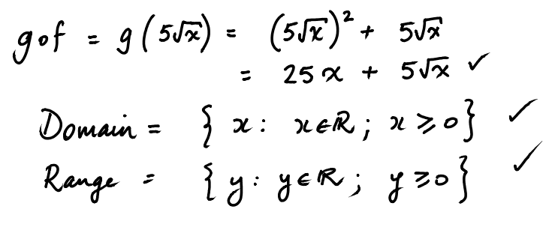

Question 3 [2, 2, 2, 1 = 7 marks]
- On the graph below accurately draw: $y=\left|x-2\right|$ and $y=\left|x+4\right|$
- Using these, or otherwise, draw $y=\left|x-2\right|-\left|x+4\right|$
- Express this as a piecewise function $f\left(x\right).$
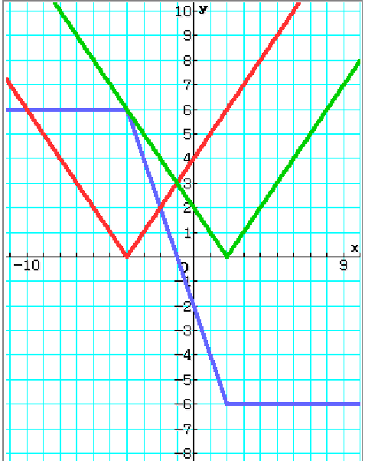

$f\left(x\right)=\left\{\begin{matrix} 6 x<-4 \\ -2x-2 -4≤x≤2 \\ -6 x>2\end{matrix}\right.$

- Use your graph to find the values of $x$ which satisfy: $\left|x-2\right|-\left|x+4\right|≥3$
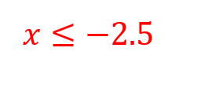

Question 4 [2 marks]
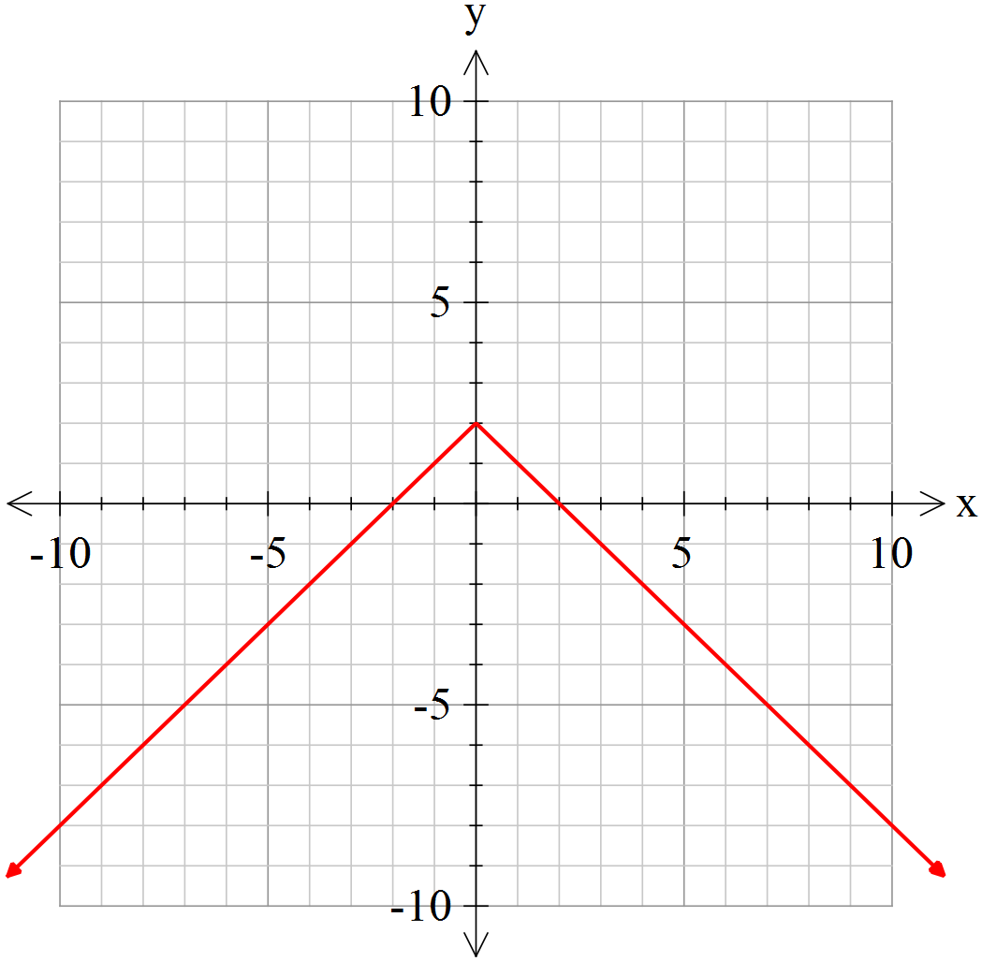Sketch the graph $y=-\left|x\right|+2$

Question 5 [2, 1 = 3 marks]
Sketch the graph of. Write the domain of.
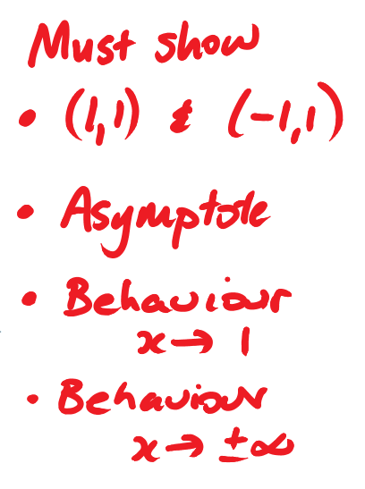
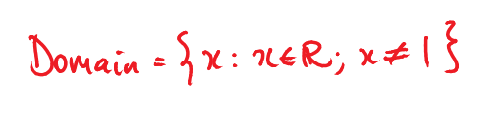
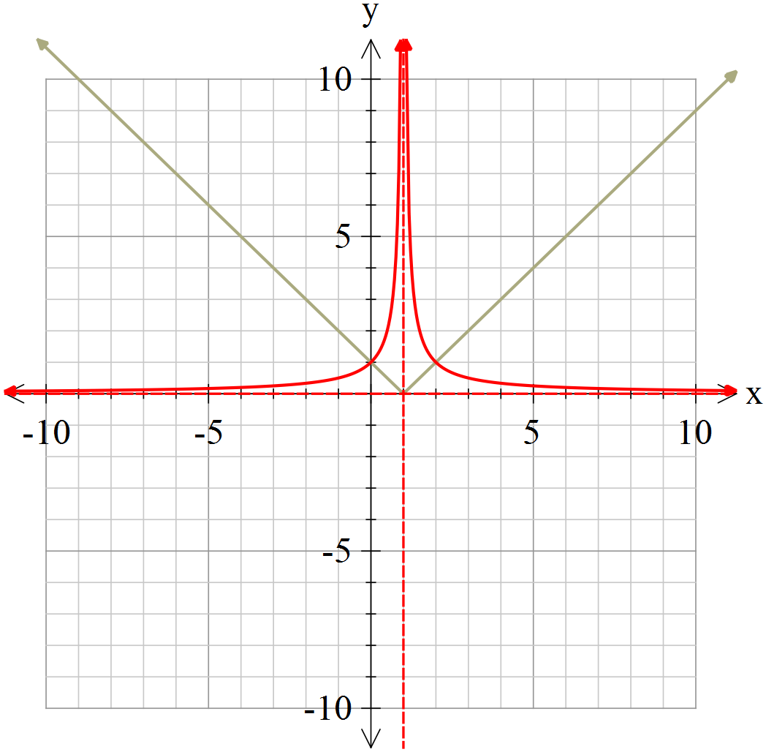
Question 6 [2 marks]
Sketch the graph of given that as shown on the graph below.

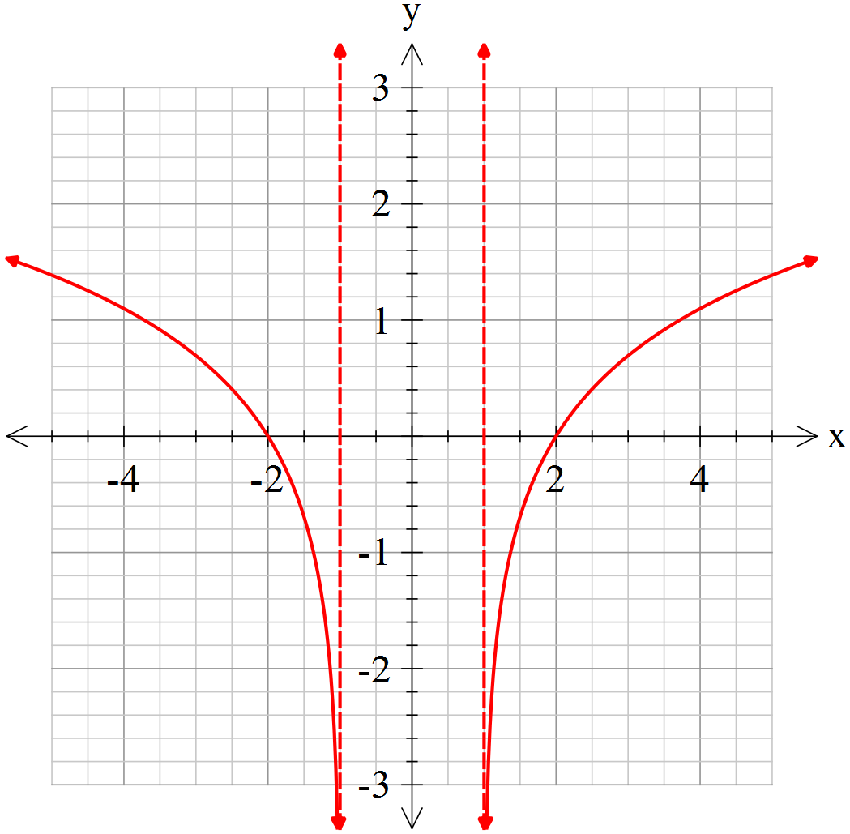


Year 12 Mathematics Specialist 2017
Test Number 2: Functions and Graph Sketching
Resource Rich
Name: _______Solutions____________________________ Teacher: DDA
Marks: 20
Time Allowed: 23 minutes
Instructions: You are permitted 1 A4 pages of notes and your calculators. Show your working where appropriate remembering you must show working for questions worth more than 2 marks.
_________________________________________________________________________
Question 7 [1 mark]
Circle all of the choices A-E which are true of the following statement.
A function can be identified as one-to-one if, for all values in the domain,

A . B . C .
D . E .

Question 8 [1, 2 = 3 mark]
Is the function $f\left(x\right)={\left(x-1\right)}^{3}+x^{2}$ one-to-one?
Justify your answer.
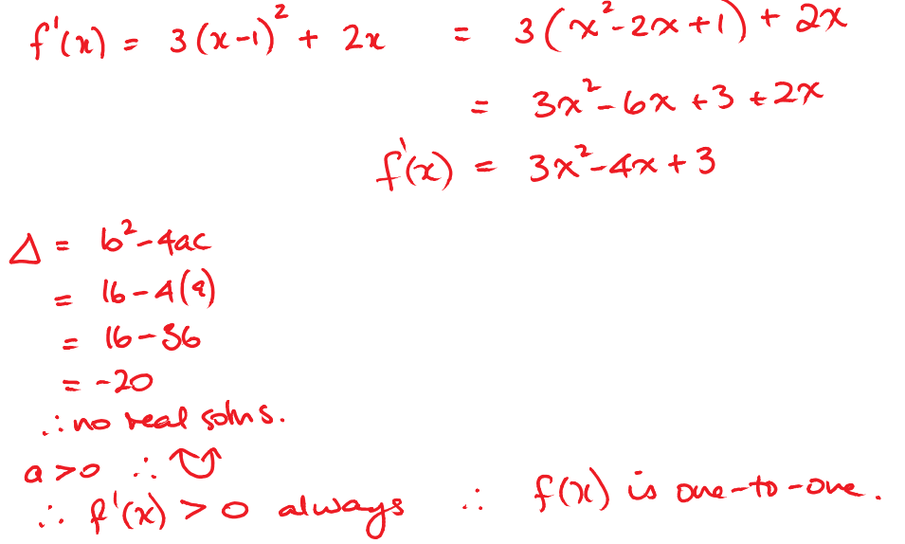

Question 9 [1, 1, 3, 3, 2 = 10 marks]
Given

- Find the following:

  - Intercepts:

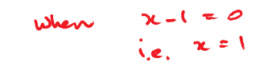
  - Vertical asymptotes:

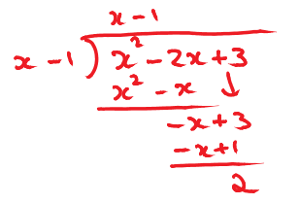
  - Behaviour of $f(x)$ as $x→±∞$ (including any oblique asymptotes):
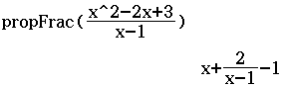
or

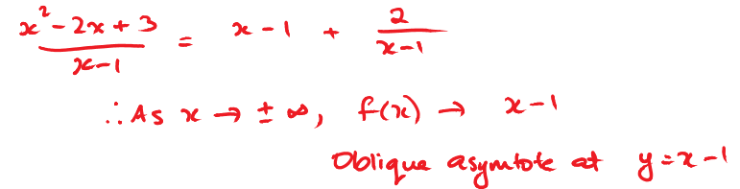

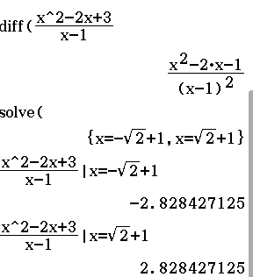
  - Stationary points (accurate to 1 d.p.):

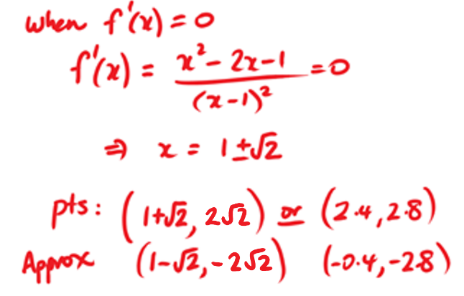
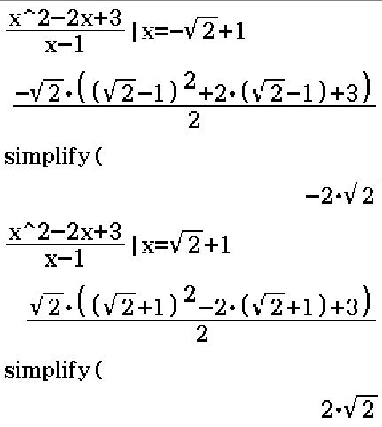

- Hence, sketch the graph of.
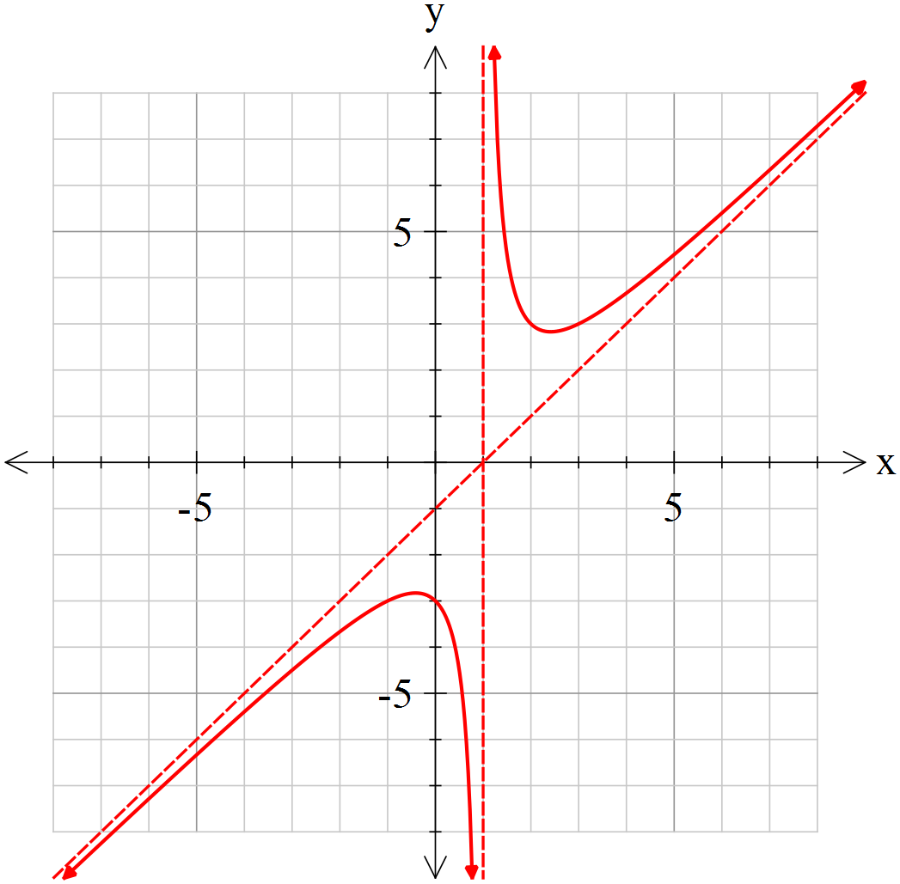

Required:
- y-int
- 2 asymptotes
- TPs
- Sketched in with arrows

Question 10 [3 marks]
If the number line drawn below represents the solution to the equation $\left|x+k\right|-2∎p$, where $∎$ represents an inequality symbol find the values of $p$ and $k$ and also determine which symbol $∎$ represents.
$$\left|x+k\right|∎p+2$$
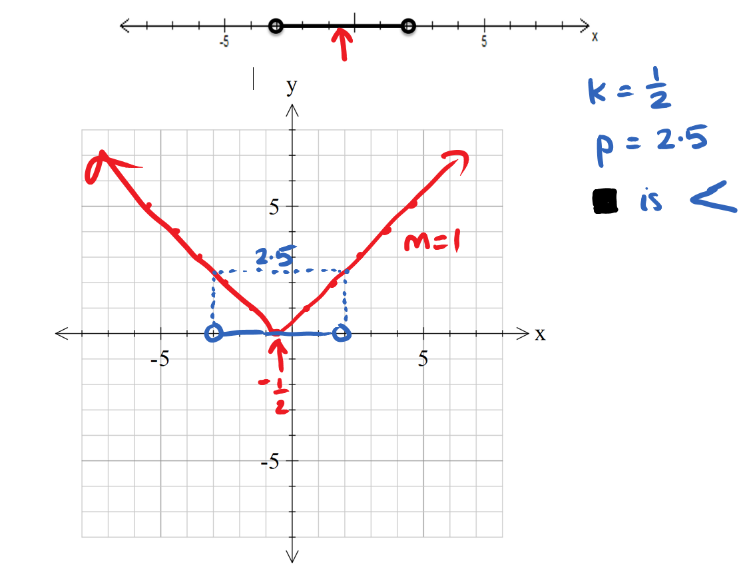
0.5
Question 11 [3 marks]
Given that $a\left|x\right|+b=\left|2x-3\right|$ is true for $0≤x≤1.5$ only, what are the values of $a$ and $b$?
You may wish to use the grid below.

